Lab 4 Notes

When the TC module is used for PWM, the buffering is typically used to make sure that the duty cycles are not altered in the middle of a PWM period, and to synchronize changes to all PWM channels. New compare/TOP values are typically written to the buffer registers instead of writing directly to the CCx registers. This way, all PWM channels can be updated at the same time (on the UPDATE event).

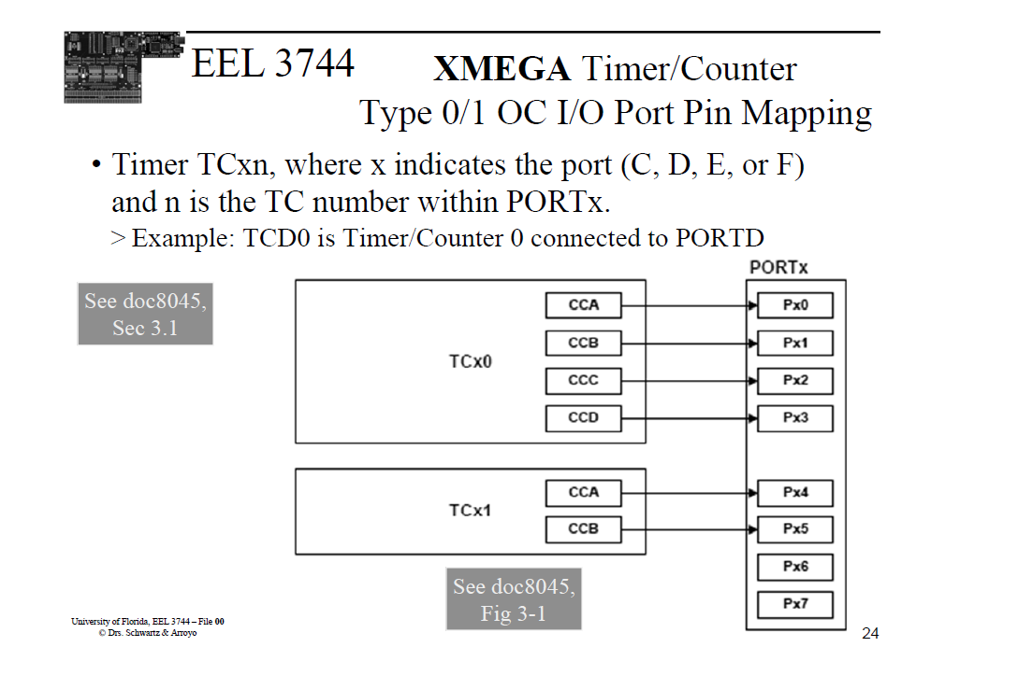

Need remapping because of this. Px6 on PORTD (which is the BLUE LED) doesn’t have CC

When CNT is lowered than CCX, waveform generation is true